






You’re No Good (Clint Ballard, Jr., 1963) (Am)
You’re No Good, Linda Ronstadt arrangement, 1975

Intro: Am D7 / Am D7 / Am D7 / Am D7

Am D7 Am D7 Am D7 Am D7
Feeling better now that we're through, Feeling better 'cause I'm over you
F G C Am D7 E7
I learned my lesson, it left a scar, Now I see how you really are

Chorus
Am D7 Am
You're no good, you're no good, You're no good.
D7 Am D7 Am D7
Baby you're no good, I'm gonna say it again
Am D7 Am
You're no good, you're no good, You're no good.
D7 Am D7
Baby you're no good

Am D7 Am D7 Am D7 Am D7
I broke a heart that's gentle and true, Well I broke a heart over someone like you.
F G C Am D7 E7
I'll beg his forgiveness on bended knee, I wouldn't blame him if he said to me. Chorus

Am D7 Am D7
I'm telling you now baby, And I'm going my way.
Am D7 Am D7
Forget about you baby, 'Cause I'm leaving to day. Chorus

Outro
D7 Am D7
Oh, oh no

Tacet
You're no good, you're no good, You're no good
Baby you're no go -oo - od

Strum  Am D7  1 2 3& 4  D D DU D |  |  | GCEA | 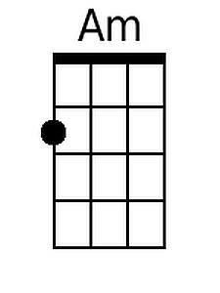 | 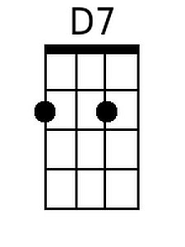 | 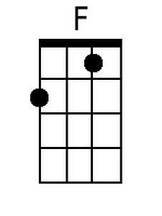 | 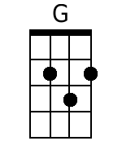 | 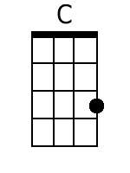
 |  |  | DGBE | 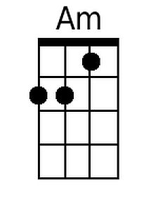 | 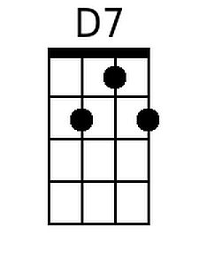 | 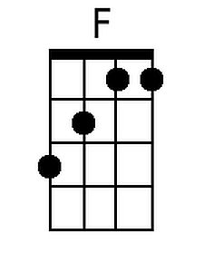 | 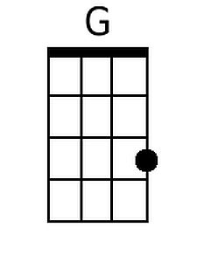 | 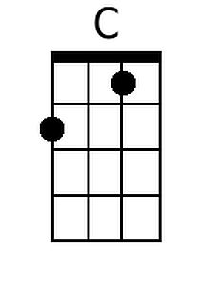

You’re No Good (Clint Ballard, Jr., 1963) (Em)
You’re No Good, Linda Ronstadt arrangement, 1975

Intro: Em A7 / Em A7 / Em A7 / Em A7

Em A7 Em A7 Em A7 Em A7
Feeling better now that we're through, Feeling better 'cause I'm over you
C D G Em A7 B7
I learned my lesson, it left a scar, Now I see how you really are

Chorus
Em A7 Em
You're no good, you're no good, You're no good.
A7 Em A7 Em A7
Baby you're no good, I'm gonna say it again
Em A7 Em
You're no good, you're no good, You're no good.
A7 Em A7
Baby you're no good

Em A7 Em A7 Em A7 Em A7
I broke a heart that's gentle and true, Well I broke a heart over someone like you.
C D G Em A7 B7
I'll beg his forgiveness on bended knee, I wouldn't blame him if he said to me. Chorus

Em A7 Em A7
I'm telling you now baby, And I'm going my way.
Em A7 Em A7
Forget about you baby, 'Cause I'm leaving to day. Chorus

Outro
A7 Em A7
Oh, oh no

Tacet
You're no good, you're no good, You're no good
Baby you're no go -oo - od

Strum  Em A7  1 2 3& 4  D D DU D |  |  | GCEA | 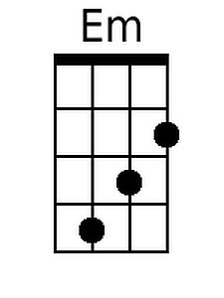 | 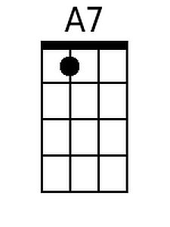 |  | 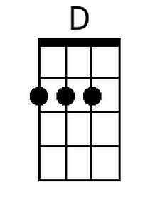
 |  |  | DGBE | 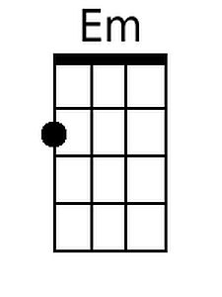 | 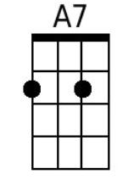 |  | 