You'll Never Walk Alone
(Oscar Hammerstein II / Richard Rodgers)
C G
When you walk through a storm hold your head up high
F C G Gm



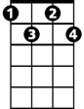
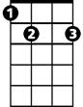
and don't be afraid of the dark
C
G
F
Fdim
E7
Dm Bb F Dm
At the end of a storm is a golden sky
Bb F Gm F E7 C7



and the sweet silver song of a lark
Gm
Dm
Bb

F Fdim
Walk on through the wind
C Fm

walk on through the rain
C7
C Em F G7
though your dreams be tossed and blown
C Eaug F D7
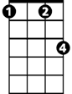
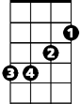
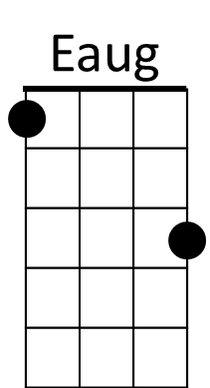

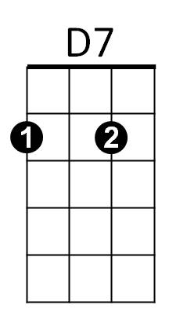
Walk on walk on with hope in your heart
Fm
Em
Am
BARITONE
C Eaug Em
and you'll never walk alone
G7 C Am F G7 C
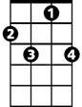

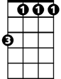

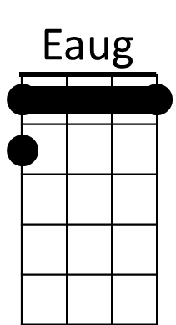
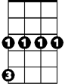
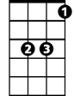

you'll ne-ver walk a – lone
C7
Fdim
Fm
Am
D7
Em
G
F
Gm
Dm
Bb
E7
C
(Repeat Song, extend last line)

