You're No Good (Clint Balard) Key A

Intro: Am D Am D Am D Am D



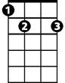

Am
F
G
E7
D
Am D Am D
Feeling better now that we're through
Am D Am D
Feeling better 'cause I'm over you
F G C
I learned my lesson, it left a scar

Am D E7
C
Now I see how you really are

Chorus:

Am D Am D Am D
You're no good, You're no good You're no good Baby you're no good
Am D
I'm gonna say it again
Am D Am D Am D Am D
You're no good You're no good You're no good Baby you're no good
BARITONE
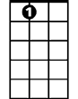


Am D Am D
D
E7
F
Am
G
I broke a heart that's gentle and true
Am D Am D
Well I broke a heart over someone like you
F G C
I'll beg his forgiveness on bended knee
Am D E7
I wouldn't blame him if he said to me
C

(Chorus)

Am D Am D
I'm telling you now baby and I'm going my way
Am D Am D
Forget about you baby 'cause I'm leaving to stay

Am D Am D Am D
You're no good, you're no good, you're no good - Baby you're no good
Am D
I'm gonna say it again
Am D Am D Am D Am D
You're no good, you're no good, you're no good - Baby you're no good - Oh, no
(TACET slowly)
You're no good, you're no good, you're no good - Baby you're no go-oo-od

(Am C D) x4

You're No Good (Clint Ballard) Key D
Bb
G
Dm
A7
C
Intro: Dm G Dm G Dm G Dm G

Dm G Dm G
Feeling better now that we're through
Dm G Dm G
Feeling better 'cause I'm over you
Bb C F
I learned my lesson, it left a scar
F
Dm G A7
Now I see how you really are

Chorus:

Dm G Dm G Dm G
You're no good, You're no good You're no good Baby you're no good
Am D
I'm gonna say it again
Dm G Dm G Dm G Dm G
You're no good You're no good You're no good Baby you're no good
BARITONE
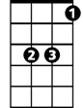

Dm G Dm G
Bb
Dm
G
I broke a heart that's gentle and true
Dm G Dm G
Well I broke a heart over someone like you
Bb C F
I'll beg his forgiveness on bended knee
Dm G A7
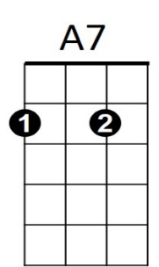
I wouldn't blame him if he said to me
F
C

(Chorus)

Dm G Dm G
I'm telling you now baby and I'm going my way
Dm G Dm G
Forget about you baby 'cause I'm leaving to stay

Dm G Dm G Dm G
You're no good, You're no good You're no good Baby you're no good
Am D
I'm gonna say it again
Dm G Dm G Dm G Dm G
You're no good You're no good You're no good Baby you're no good Oh, no

(TACET Slowly)
-=You're no good You're no good You're no good Baby you're no go-oo-od

(Dm F G) x4

