Whispering Hope (Septimus Winner, 1868)
3/4 Time (Waltz) – Key of C

Intro (4 Measures): C G C G
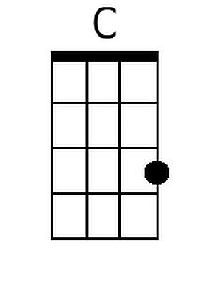
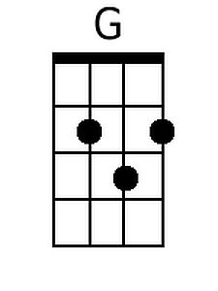
C F C G7 C
1. Soft, as the voice of an angel, Breathing a lesson un-heard.
C (C7) F C G7 C
Hope, with a gentle per-uasion, Whispers her comforting word:
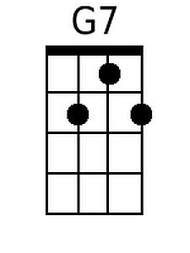
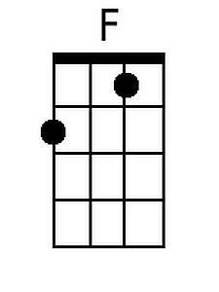
C Em (G7) C Am G D7 G G7
“Wait till the darkness is o - ver, Wait till the tempest is done.
C (F) C G7 C
Hope for the sunshine to-morrow, After the shower is gone.”

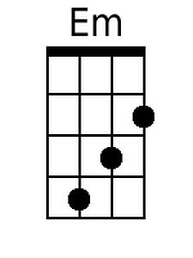
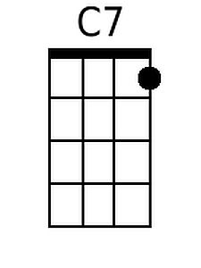
Chorus:
G7 C G7 C
Whispering hope, Oh how welcome Thy voice,
F C G7 C
Making my heart, In its sorrow re-joice.
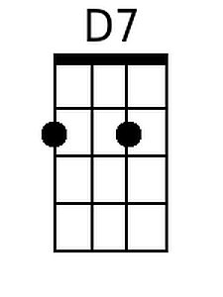
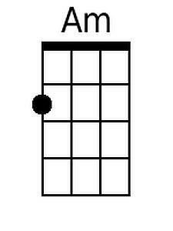
C F C G7 C
2. If in the dusk of the twilight, Dim be the region a-far
C (C7) F C G7 C
Will not the deepen-ing darkness, Brighten the glimmering star
C Em (G7) C Am G D7 G G7
Then when the night is u - pon us, Why should the heart sink a-way
C (F) C G7 C
When the dark midnight is over, Watch for the breaking of day. Chorus

C F C G7 C
3. Hope, as an anchor so steadfast, Rends the dark veil for the soul,
C (C7) F C G7 C
Whither the Master has entered, Robbing the grave of its goal;
C Em (G7) C Am G D7 G - G7
Come then, oh, come, glad fru – I - tion, Come to my sad weary heart;
C (F) C G7 C
Come, O Thou blest hope of glory, Never, oh, never de-part. Chorus

C G7 C F C
Outro: - Slowing in its sorrow re-joice.

Note: Chords in parentheses – as: (C7) – are played on the third note of a verse and may be omitted.

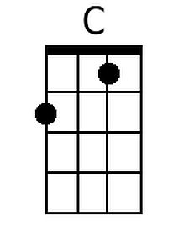
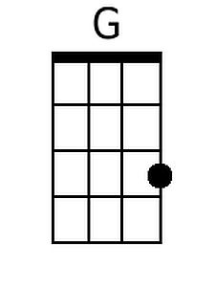
Bari:
 |  | 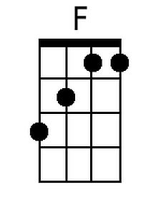 | 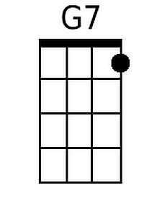 | 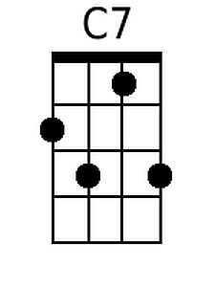 | 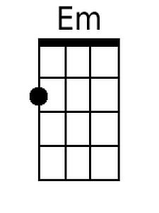 | 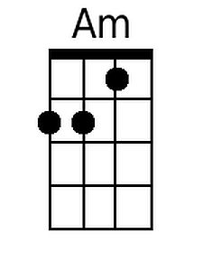 | 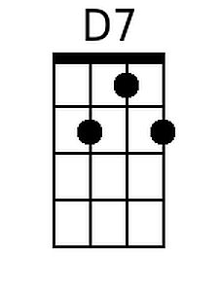

Whispering Hope (Septimus Winner, 1868)
3 / 4 Time (Waltz) - Key of G

Intro (4 Measures): G D G D
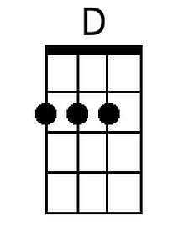
G C G D7 G
1. Soft, as the voice of an angel, Breathing a lesson un-heard.
G (G7) C G D7 G
Hope, with a gentle per - uasion, Whispers her comforting word:
G Bm (D7) G Em D A7 D D7
"Wait till the darkness is o - ver, Wait till the tempest is done.
G (C) G D7 G
Hope for the sunshine to-morrow, After the shower is gone."

Chorus:
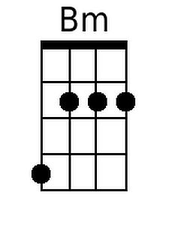
D7 G D7 G
Whispering hope, Oh how welcome Thy voice,
C G D7 G
Making my heart, In its sorrow re-joice.

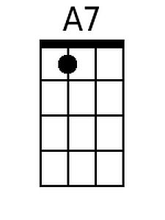
G C G D7 G
2. If in the dusk of the twilight, Dim be the region a-far
G (G7) C G D7 G
Will not the deepen-ing darkness, Brighten the glimmering star
G Bm (D7) G Em D A7 D D7
Then when the night is u - pon us, Why should the heart sink a-way
G (C) G D7 G
When the dark midnight is over, Watch for the breaking of day. Chorus

G C G D7 G
3. Hope, as an anchor so steadfast, Rends the dark veil for the soul,
G (G7) C G D7 G
Whither the Master has entered, Robbing the grave of its goal;
G Bm (D7) G Em D A7 D - D7
Come then, oh, come, glad fru - i- tion, Come to my sad weary heart;
G (C) G D7 G
Come, O Thou blest hope of glory, Never, oh, never de-part. Chorus

G D7 G C G
Outro: - Slowing in its sorrow re-joice.

Note: Chords in parentheses – as: (G7) – are played on the third note of a verse and may be omitted.

Bari:
 | 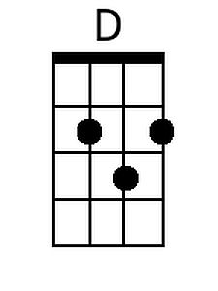 |  |  |  | 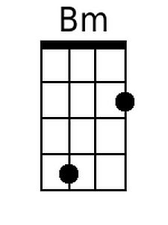 |  | 